2014-2015 Lakeland Montessori Schoolhouse
Upper Elementary-Explorers Book Reports Orientation Handout
Students will be assigned a book report every other month. Each book chosen should follow the given genre. The following list gives a tentative schedule of the months and possible genres.

September - Fiction: Newbery Winner or Newbery Honor Book
November-Non-Fiction
January - Poetry
March - Historical Fiction
May - Student Choice
See the following website for suggested Newbery Medal and Newbery Honor books: http://www.ala.org/alsc/awardsgrants/bookmedia/newberymedal/newberyhonors/newberymedal
2014-2015 Sunshine State Young Readers Award List can be found at:
http://www.fldoe.org/bii/Library_Media/pdf/ssyrl.pdf
AR BookFinder is also another good way to discover and locate information on various books for book reports. http://www.arbookfind.com/default.aspx

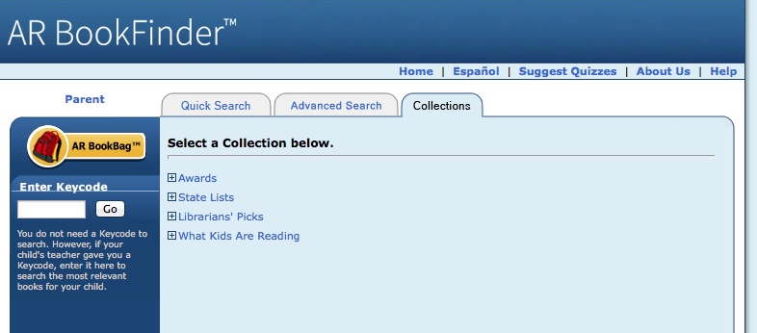

Note: The length of the book should be appropriate to the student’s reading ability and should be able to be completed within a two week time period. Each book report will require a written report, a visual aid, and a brief oral presentation. Students will receive a guideline and rubric for each report outlining specific details.

